Aim:

Write a Python function **countX(lst, x)** to count the number x in a given list of numbers.

Program:

def countX(lst,a):

c=0

for i in range(0,len(lst)):

if lst[i]==a:

c+=1

print(c)

lst=[]

x=int(input())

for i in range(x):

lst.append(int(input()))

a=int(input())

countX(lst,a)

Link:

http://103.53.53.18/mod/vpl/forms/edit.php?id=230&userid=1680#

Output:

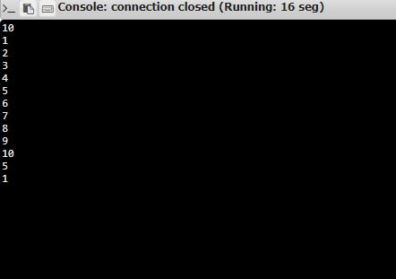

Result:

Python function **countX(lst, x)** to count the number x in a given list of numbers is written and the the Occurance of the Value is Found